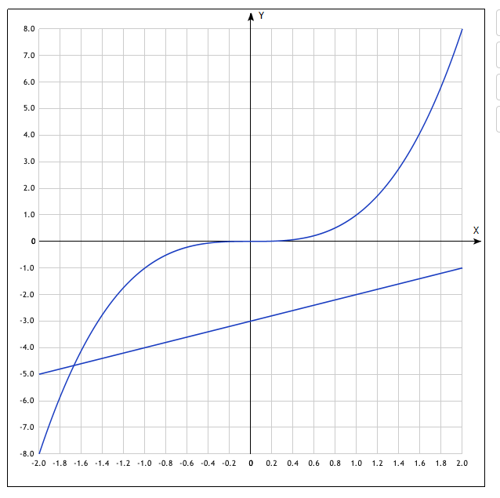

*y*(*x*)=*x*3

[Показать таблицу точек](javascript:void(0);)

|  |  |
| --- | --- |
| **x** | **y** |
| -2.0 | -8 |
| -1.4 | -2.74 |
| -1.2 | -1.73 |
| -1.0 | -1 |
| -0.8 | -0.51 |
| -0.6 | -0.22 |
| -0.4 | -0.06 |
| -0.2 | -0.01 |
| 0 | 0 |
| 0.2 | 0.01 |
| 0.4 | 0.06 |
| 0.6 | 0.22 |
| 0.8 | 0.51 |
| 1.0 | 1 |
| 1.2 | 1.73 |
| 1.4 | 2.74 |
| 1.6 | 4.1 |
| 1.8 | 5.83 |
| 2.0 | 8 |

*y*(*x*)=*x*−3

[Показать таблицу точек](javascript:void(0);)

|  |  |
| --- | --- |
| **x** | **y** |
| -2.0 | -5 |

2.0 -1