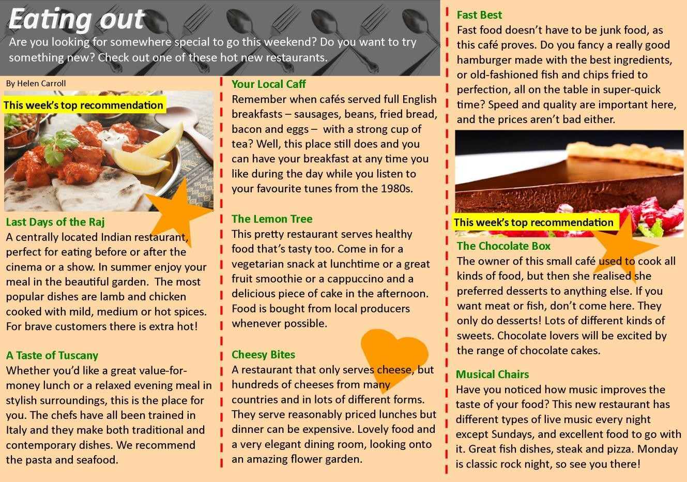

Check your understanding: matching
Match the people with the best restaurant for them. Write the restaurant names below.

Your Local Caff | The Lemon Tree | Fast Best
The Chocolate Box | Last Days of the Raj | A Taste of Tuscany

1.
My girlfriend and I are vegetarian. Could you recommend a suitable restaurant for us?

Restaurant:

Tom, aged 18

2.
My friend has a sweet tooth and I want to take her somewhere special this weekend.

Restaurant:

Lucy, aged 16

3.
My mates and I all love spicy food. Can you recommend somewhere good for us to go tonight?

Restaurant:

Dino, aged 21

4.
I only get 30 minutes off for lunch and I'm in a hurry. Where can I get something quick to eat?

Restaurant:

Melissa, aged 27

5.
Breakfast is the most important meal of the day in my opinion. Do you know anywhere that serves a good brekkie?

Restaurant:

Micky, aged 38

6.
We love Italian food, especially pasta. Everyone loves Italian, don't they? Any good Italians near here?

Restaurant:

Momo, aged 22
Write the names of restaurants from the article in the box.

- Which restaurant(s) serve hot and spicy food?

- Which restaurant(s) only have desserts and sweets?

- In which restaurant(s) can you listen to some great music?

- Which restaurant(s) are good for people who don't eat meat?

- Which restaurant(s) employ staff trained in Europe?

- Which restaurant(s) serve an all-day breakfast including sausages, bacon and eggs?

