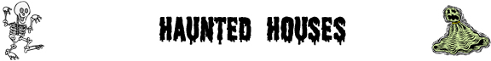

Fill in the blanks with the words in the boxes.

Haunted Houses
ghosts | strange | Haunted |  | happened |  | past
_____________________ houses are houses that have _____________________ in them. They are often houses where something terrible has _____________________ in the _____________________ and _____________________, unexplained things happen in the present.
Haunted House Exteriors
broken | deserted | overgrown |  | roof |  | graveyard
Haunted houses are usually old and _____________________. They have _____________________ windows and missing shingles on the _____________________. The garden is _____________________ with weeds and there is sometimes a _____________________ at the side of the house.
Haunted House Interiors
cobwebs | Bats | walls |  | dust |  | messy
Because the houses are deserted, they are usually _____________________. The furniture is covered with _____________________ and there are _____________________ made by spiders in every corner of the house. _____________________ make their home in the attic and mice live in holes in the _____________________.
Haunted House Sounds
slam | hear | moans |  | footsteps |  | spend
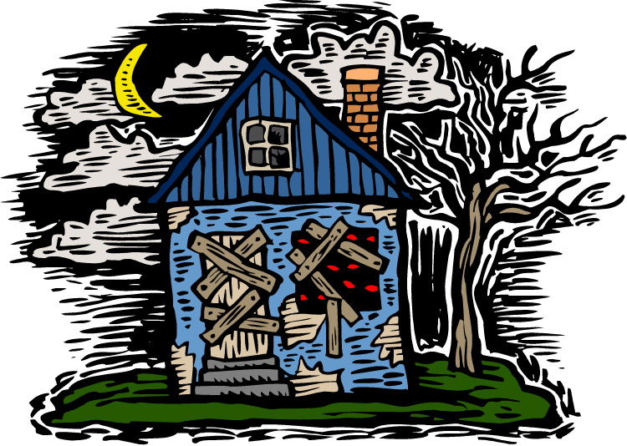 |  |  | If you _____________________ the night in a haunted house, you will _____________________ many strange noises such as _____________________ walking down the hall. As well, doors _____________________ shut by themselves and strange _____________________ can be heard throughout the night.
©2008 www.bogglesworldesl.com

