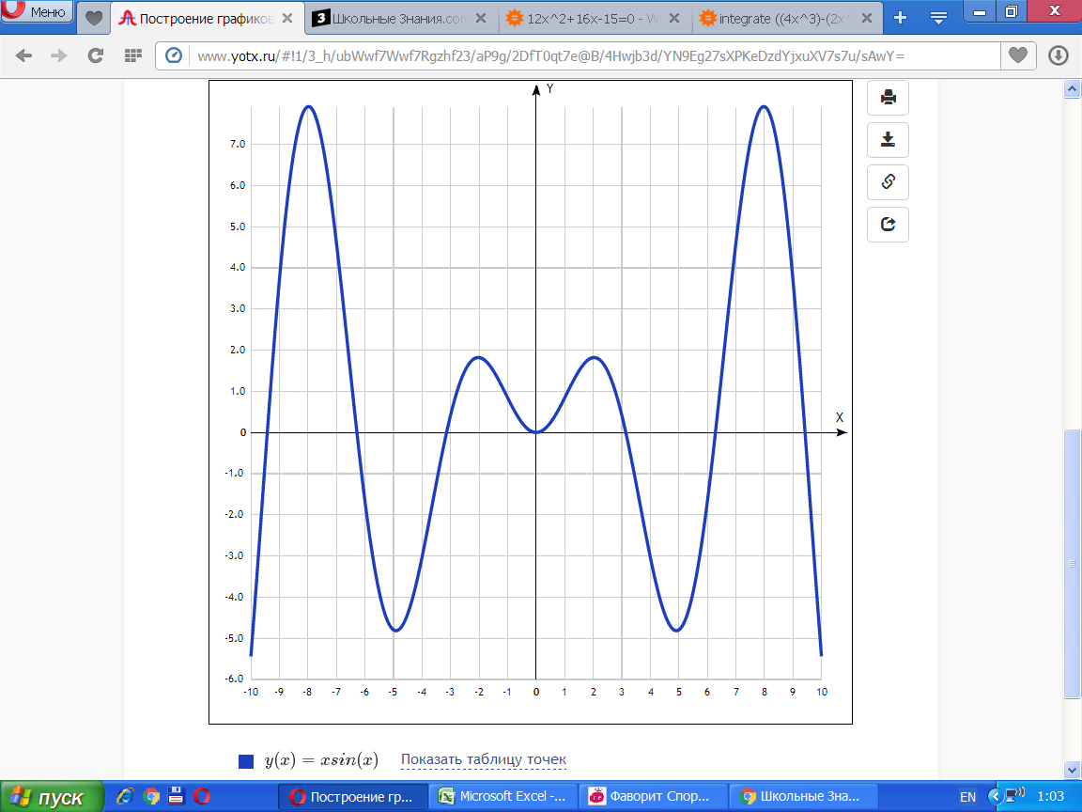

y(x)=xsin(x)y(x)=xsin(x)

[Показать таблицу точек](javascript:void(0);)

|  |  |
| --- | --- |
| **x** | **y** |
| -10 | -5.44 |
| -9 | 3.71 |
| -8 | 7.91 |
| -7 | 4.6 |
| -6 | -1.68 |
| -5 | -4.79 |
| -4 | -3.03 |
| -3 | 0.42 |
| -2 | 1.82 |
| -1 | 0.84 |
| 0 | 0 |
| 1 | 0.84 |
| 2 | 1.82 |
| 3 | 0.42 |
| 4 | -3.03 |
| 5 | -4.79 |
| 6 | -1.68 |
| 7 | 4.6 |
| 8 | 7.91 |
| 9 | 3.71 |
| 10 | -5.44 |