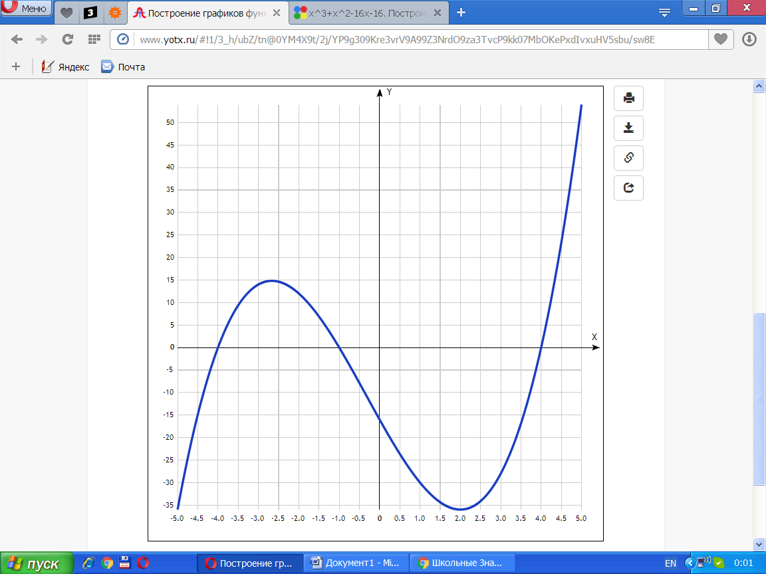

[Таблица точек](javascript:void(0);)

|  |  |
| --- | --- |
| **x** | **y** |
| -5.0 | -36 |
| -4.5 | -14.9 |
| -4.0 | 0 |
| -3.5 | 9.4 |
| -3.0 | 14 |
| -2.5 | 14.6 |
| -2.0 | 12 |
| -1.5 | 6.9 |
| -1.0 | 0 |
| -0.5 | -7.9 |
| 0 | -16 |
| 0.5 | -23.6 |
| 1.0 | -30 |
| 1.5 | -34.4 |
| 2.0 | -36 |
| 2.5 | -34.1 |
| 3.0 | -28 |
| 3.5 | -16.9 |
| 4.0 | 0 |
| 4.5 | 23.4 |
| 5.0 | 54 |