**Прочитайте текс и напишите о своем любимой животном, отвечая на вопросы и опираясь на этот текст.**

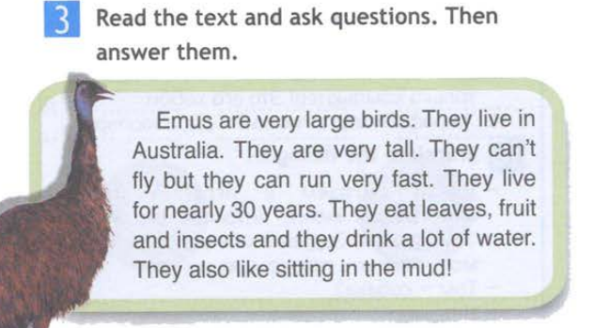

1. What does your favourite animal look like?
2. Where does it live?
3. How long does it live?
4. What does it like?
5. What does it eat?
6. Why do you like this animal?