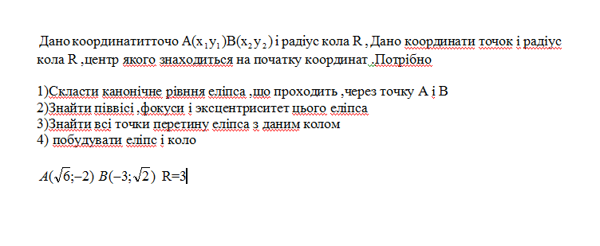

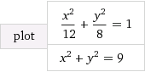

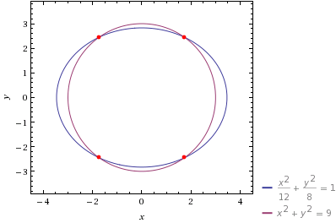

solve x^2\/12+(9-x^2\/8) = 1

x = ±(8 sqrt(3))

x = -sqrt(3) ~~ -1.73205 and y = -sqrt(6) ~~ -2.44949

x = -sqrt(3) ~~ -1.73205 and y = sqrt(6) ~~ 2.44949

x = sqrt(3) ~~ 1.73205 and y = -sqrt(6) ~~ -2.44949

x = sqrt(3) ~~ 1.73205 and y = sqrt(6) ~~ 2.44949