**December, 1**

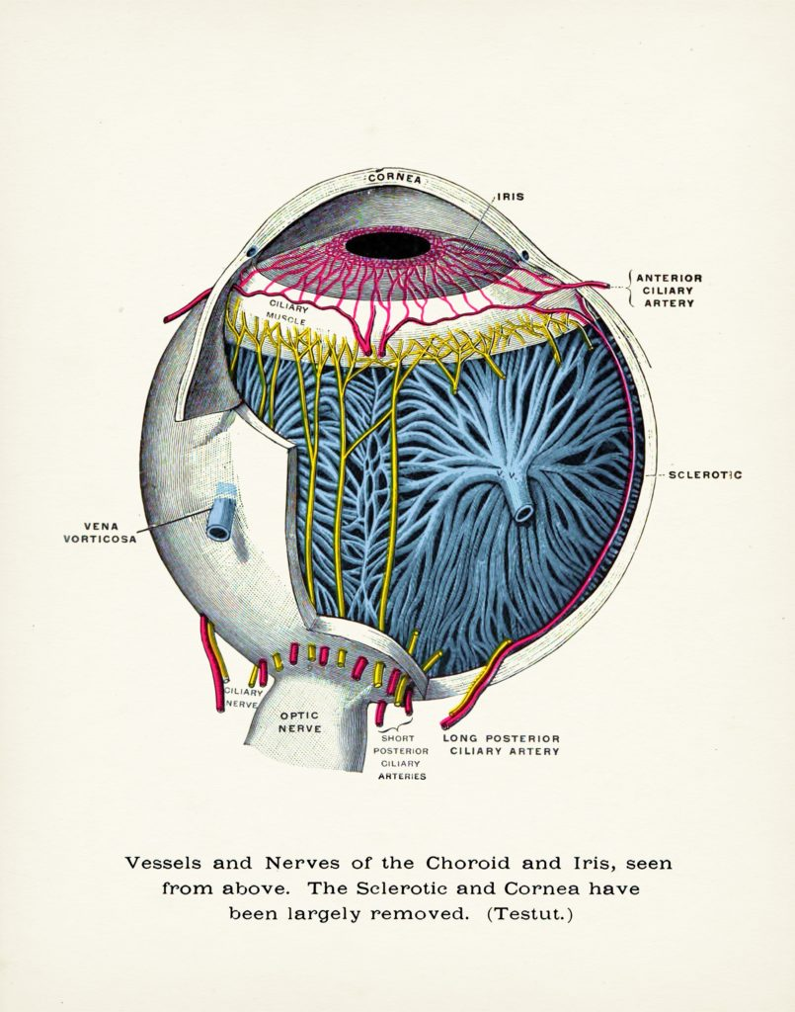

**OPHTHALMOLOGY.**

**EYE DISEASES.**

**TERMINOLOGY.**

1. **Vocabulary. Give the translation of the words below.**

|  |  |
| --- | --- |
| r**e**tina /ˈretɪnə/ –  eyeball –  bony orbit –  sclera /'sklɪərə/ –  cornea –  iris /'aɪərɪs/ –  pupil –  lens –  ciliary body –  optic nerve –  contraction –  to enable –  vitreous humour –  aqueous humour –  ch**o**roid /ˈkɔːrɔɪd/ –  rods and cones –  refraction –  even / 'iːvən / –  opaque / oʊ 'peɪk / – | ‘in conjunction with’ –  to align –  squint –  eyelids –  tear –  suspensory ligaments –  microphthalmos or microphthalmia –  fogginess /'fɒginəs/ –  congenital –  nystagmus –  conjunctivitis /kəndʒʌŋktɪ'vaɪtɪs/ –  retinal detachment –  myopic /maɪ'ɒpɪk/ –  to lubricate / 'luːbrɪkeɪt/ –  to bend (the light) –  diffusion –  at the rear / rɪə/ –  bare / beəʳ/ –  to conduct / kən 'dʌkt / – |

1. **Watch the learning video “Anatomy of Eye”. And be ready to answer the questions**

<https://www.youtube.com/watch?v=PSa5g2K_6uc>

1. What are the functions of the eyelids? - ___________________________________________.
2. What is conjunctiva for? - _____________________________________________.
3. Which element of the eye is called a medium for diffusion of oxygen and nutrients? - ________________________________________________________.
4. Where are the radial and circular muscles located?

______________________________________________.

1. What is lens like in its nature? - _________________________________________________.
2. What helps the lens to focus on near and distant objects?

______________________________________________.

1. Which organ is called the light sensitive layer of the eye?

______________________________________________.

1. What eye structural element prevents from internal refraction of light?

______________________________________________.

1. What are the tree types of tears? - ______________________________________________.
2. Which type of tears contains more proteins and various hormones that act as natural painkillers? - _________________________________________________.
3. **Look at the structure of the eye. Read the description of the eye structure and complete the scheme.**

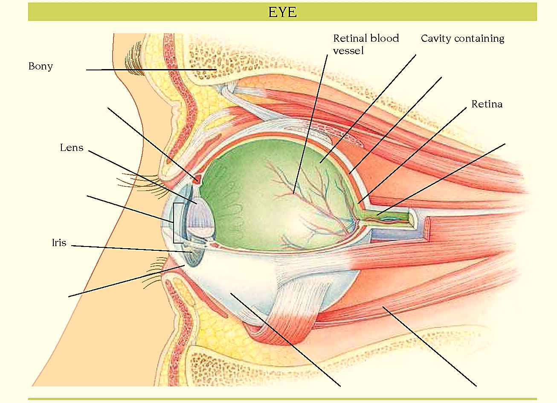

8)

2)

9)

7)

1)

6)

5)

4)

3)

The eye consists of structures that focus an image on to the retina at the back of the eye and nerve cells that convert this image into electrical impulses. These impulses are carried by the optic nerve to the visual cortex (an area at the back of the brain concerned with vision) for interpretation.

The eyeballs lie within the bony orbits. Each eyeball is moved by six delicate eye muscles. The eye has a tough outer coat, the sclera. At the front of the sclera, the transparent corneaserves as the main “lens” of the eye and does most of the focusing. Behind the cornea is a chamber of watery fluid, at the back of which is the iriswith its pupil, which appears black. Tiny muscles alter the size of the pupil in response to changes in light intensity to control the amount of light entering the eye.

Immediately behind the iris is the lens, suspended by fibres /faiberz/ from a circular muscle ring called the ciliary body. Contraction of the ciliary body changes the shape of the lens, enabling fine focusing. Behind the lens is the main cavity of the eye, containing a clear gel, the vitreous humour. On the inside of the back of the eye is the retina, a complex structure of nerve tissue. The retina requires a constant supply of oxygen and glucose, and a network of blood vessels, the choroid, surrounds it. The eyes work in conjunction with each other, under the control of the brain, aligning themselves on an object so that a clear image is formed on each retina. If necessary, the eyes sharpen images by changing focus in an automatic process called accommodation.

1. **Read the statements and chose whether they are True (T) or False (F).**
2. _____ The eyes work in conjunction with each other, under the control of the brain.
3. _____ The retina converts the image into electrical impulses.
4. _____ Each eyeball is moved by five delicate eye muscles.
5. _____ Tiny muscles alter the size of the pupil in response to changes in light intensity in order to control the amount of light entering the eye.
6. _____ Compression of the ciliary body changes the shape of the lens, enabling better focusing.
7. **Match the terms with their definitions.**

|  |  |
| --- | --- |
| *a) macula*  *b) pupil*  *c) iris*  *d) cornea*  *e) retina*  *f) lens*  *g) optic nerve*  *h) conjunctiva* | 1) front part or “window” of the eye;  2) collection of nerve endings attached to the retina connecting the eyeball to the “seeing” centres of the brain;   3) mucous membrane that covers the front of the eye and lines the inside of the eyelids;  4) that part of the retina responsible for central or “eagle eye” vision;  5) part of the eye that focuses onto the retina;  6) innermost layer of the eye composed of light sensitive cells, which pick up the images seen by the eye;  7) “coloured” part of the eye;  8) dark circular opening in the centre of the iris of the eye, which varies in size to regulate the amount of light reaching the retina. |

1. **Read the sentences below and the text. Insert the sentences (A–H) into the text (there is one odd sentence).**
2. It is usually a symptom of a squint, especially of paralytic squint, in which paralysis of 1 or more of the eye muscles impairs eye movement.
3. Small tumours can be treated by laser, but the eye may need to be removed to avoid spread of the tumour.
4. Endophthalmitis (infection within the eye) can occur as a result of eye injury or infection elsewhere in the body.
5. The pressure inside the eyeball becomes raised and it can lead to permanent loss of vision.
6. The eyelids may be unable to close, and vision may become blurred due to drying of the *cornea.*
7. Urgent treatment is required and usually involves surgical repair of the underlying tear.
8. Rarely, babies are born with *microphthalmos.*
9. This causes a severe pain in and above the eye, fogginess of vision, and perception of haloes around lights at night.

**EYE DISORDERS AND DISEASES**

Many eyedisorders are minor, but some can cause loss of vision unless treated. *Squint* is sometimes present at birth. 1) __________________________. Other congenitaldisorders that affect the eye are *nystagmus*, *albinism*, and developmental abnormalities of the cornea and retina.

*Conjunctivitis* is the most common eye infection and rarely affects vision. *Trachoma* or severe bacterial conjunctivitis can impair vision. Corneal infections can lead to blurred vision or corneal *perforation* if not treated early. 2) ____________________________________________. Various *vitamin* deficiencies (particularly of vitamin A) can affect the eye. This may lead to *xerophthalmia*, *night blindness*, or, ultimately, *keratomalacia*. *Ametropia* is a general term for any focusing error, such as *astigmatism, myopia*, or *hypermetropia*. *Presbyopia* is the progressive loss with age of the ability to focus at close range. *Amblyopia* is often due to squint. Narrowing, blockage or *inflammation* of the blood vessels of the *retina* may cause partial or total loss of vision.

Separation of the retinafrom the outer layers at the back of the eye is called ***retinal detachment****.* It may follow an eye injury but usually occurs spontaneously. It is usually preceded by a *retinal tear*, and is more common in highly myopic (short-sighted) people and in people who have had cataract surgery. The detachment is painless. The first symptom is either bright flashes of light at the edge of the field of vision, or a black “drape” obscuring vision. 3) _____________________________________. If the macula (site of central vision) has not been detached, the results can be excellent.

***Double vision*** is also known as *diplopia*, the seeing of 2 instead of 1 visual image of a single object. 4) ____________________________________________________. Other causes include a tumour in the eyelid or a tumour or blood clot behind the eye. Double vision can also occur in *exophthalmos*, when the eyeballs protrude because of an underlying hormonal disorder. A child with squint needs treatment to prevent *amblyopia* (lazy eye). In adults, double vision needs immediate investigation.

***Glaucoma*** is acondition in which the pressure of the fluid in the eye is abnormally high, causing the compression and obstruction of the small blood vessels that nourish the retina. This may result in nerve fibre destruction and gradual loss of vision. The most common form of glaucoma is chronic simple (open-angle) glaucoma, which rarely occurs before age 40 and often causes no symptoms until visual loss is advanced. In acute (closed-angle) glaucoma, there is a sudden obstruction to the outflow of aqueous humour from the eye and the pressure rises suddenly. 5) _________________________.

***Exophthalmos*** is a protrusion of one or both eyeballs caused by a swelling of the soft tissue in the eye socket. It is most commonly associated with *thyrotoxicosis*. Other causes include an eye tumour, inflammation, or an *aneurysm* behind the eye. Exophthalmos may restrict eye movement and cause doublevision. In severe cases, increased pressure in the socket may restrict blood supply to the optic nerve, causing blindness. 6) __________________________________________________*.*

Treatment of the thyroid disorder may relieve the exophthalmos, but exophthalmos may persist even if thyroid function returns to normal. Early treatment of the condition usually returns vision to normal. Occasionally, surgery may be required to relieve pressure on the eyeball and optic nerve.

Tumoursof the eye are rare. When eye tumours do occur, they are usually cancerous and painless. ***Retinoblastoma***is a cancerous tumour of the retinathat occurs in one or both eyes and most often affects children. It may be treated by radiotherapy, laser treatment, or cryosurgery, but the eye may have to be removed to prevent spread of the tumour. ***Malignant melanoma***is a cancer of the choroid. It usually affects older people. There are no symptoms in the early stages, but it eventually causes *retinal detachment* and distortion of vision. 7) ______________________________. ***Basal cell carcinoma***is the most common type of tumour affecting the eyelid. It usually has a crusty central crater and a rolled edge. In the early stages, treatment may be possible by surgery, radiotherapy, or cryosurgery.

1. **Complete the sentences**.
2. *Exophthalmos*is _______________________________________________**.**
3. *Malignant melanoma*is _________________________________________**.**
4. *Glaucoma*is ___________________________________________________**.**
5. *Conjunctivitis* is _______________________________________________**.**
6. *Diplopia* is ____________________________________________________**.**