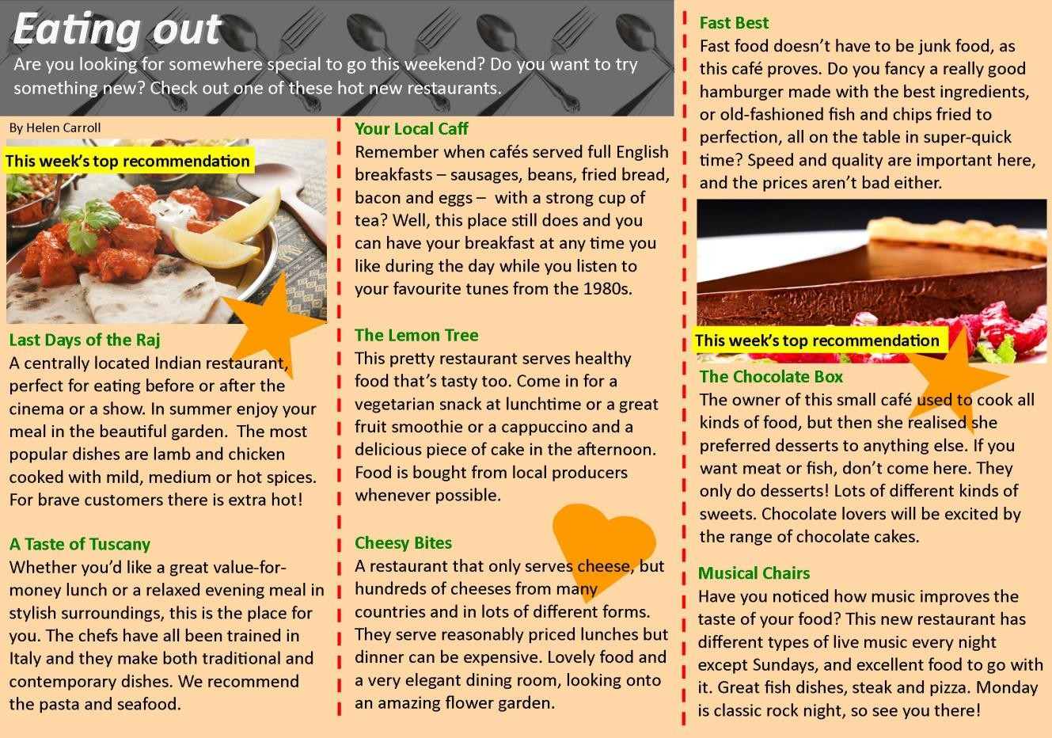

Check your understanding:matching
Match the people with the best restaurant for them. Write the restaurant names below.

Your Local Caff | The Lemon Tree | Fast Best
The Chocolate Box | Last Days of the Raj | A Taste of Tuscany

1.
My girlfriend and I are vegetarian. Could you recommend a suitable restaurant for us?

Restaurant: The Lemon Tree

Tom, aged 18

2.
My friend has a sweet tooth and I want to take her somewhere special this weekend.

Restaurant: The Chocolate Box

Lucy, aged 16

3.
My mates and I all love spicy food. Can you recommend somewhere good for us to go tonight?

Restaurant: Last Days of the Raj

Dino, aged 21

4.
I only get 30 minutes off for lunch and I'm in a hurry. Where can I get something quick to eat?

Restaurant: Fast Best

Melissa, aged 27

5.
Breakfast is the most important meal of the day in my opinion. Do you know anywhere that serves a good brekkie?

Restaurant: Your Local Caff

Micky, aged 38

6.
We love Italian food, especially pasta. Everyone loves Italian, don't they? Any good Italians near here?

Restaurant: A Taste of Tuscany

Momo, aged 22
Write the names of restaurants from the article in the box.

- Which restaurant(s) serve hot and spicyfood?
Last Days of the Raj
The Chocolate Box
Music Chairs
The Lemon Tree,The Chocolate Box, Cheesy Bites
A Taste of Tuscany
Your Local Caff

- Which restaurant(s) only have desserts and sweets?

- In which restaurant(s) can you listen to some greatmusic?

- Which restaurant(s) are good for people who don't eatmeat?

- Which restaurant(s) employ staff trained in Europe?

- Which restaurant(s) serve an all-day breakfast including sausages, bacon andeggs?

