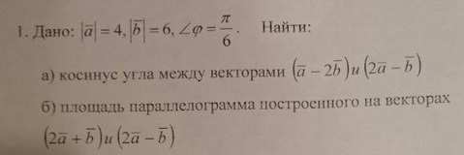
$$\begin{aligned}\left|\overline{a}−2\overline{b}\right|=\sqrt{\left(\overline{a}−2\overline{b}\right)\left(\overline{a}−2\overline{b}\right)}=\sqrt{{\left(\overline{a}\right)}^{2}−4\overline{a}\overline{b}+4{\left(\overline{b}\right)}^{2}}=\sqrt{4^{2}−4∗4∗6\text{*cos}\left(\frac{π}{6}\right)+4∗6^{2}}= \\ 4\sqrt{1−6\text{*cos}\left(\frac{π}{6}\right)+9}=4\sqrt{\text{10}−3∗\sqrt{3}} \\ \left|\overline{2a}−\overline{b}\right|=\sqrt{\left(2\overline{a}−\overline{b}\right)\left(2\overline{a}−\overline{b}\right)}=\sqrt{4{\left(\overline{a}\right)}^{2}−4\overline{a}\overline{b}+{\left(\overline{b}\right)}^{2}}=\sqrt{4∗4^{2}−4∗4∗6\text{*cos}\left(\frac{π}{6}\right)+6^{2}}= \\ 4\sqrt{4−6\text{*cos}\left(\frac{π}{6}\right)+\frac{9}{4}}=4\sqrt{4−3∗\sqrt{3}+\frac{9}{4}} \\ \left(\overline{a}−2\overline{b}\right)\left(2\overline{a}−\overline{b}\right)=2{\left(\overline{a}\right)}^{2}+2{\left(\overline{b}\right)}^{2}−5\overline{a}\overline{b}=2∗4^{2}+2∗6^{2}−5∗4∗6\text{*cos}\left(\frac{π}{6}\right)=\text{32}+\text{72}−\text{60}∗\sqrt{3}= \\ \text{104}−\text{60}∗\sqrt{3}=\left|\overline{a}−2\overline{b}\right|∗\left|\overline{2a}−\overline{b}\right|\text{*cos}(x) \\ \text{cos}(x)=\frac{\text{104}−\text{60}∗\sqrt{3}}{4\sqrt{\text{10}−3∗\sqrt{3}}∗4\sqrt{4−3∗\sqrt{3}+\frac{9}{4}}}=\frac{\text{26}−\text{15}∗\sqrt{3}}{\sqrt{\text{10}−3∗\sqrt{3}}∗2\sqrt{\text{25}−\text{12}∗\sqrt{3}}}\end{aligned}$$

