http://www4b.wolframalpha.com/Calculate/MSP/MSP85622f0iaah3g104g4e00005c6hh0c569b6056c?MSPStoreType=image/gif&s=11&w=356.&h=37.  
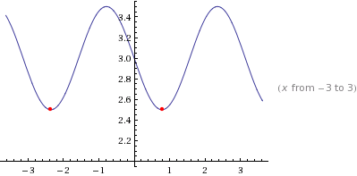  
  
http://www4a.wolframalpha.com/Calculate/MSP/MSP151ec1h9c939b01gbc0000114df81d5a59hd5g?MSPStoreType=image/gif&s=22&w=149.&h=42.=  
http://www4a.wolframalpha.com/Calculate/MSP/MSP12681dcgaeebgh7eb1hi00005ec3a50ih98g74fa?MSPStoreType=image/gif&s=17&w=212.&h=18.