**The Pleasure of Travelling**

Sandra and Paul were going to Florence. They **(pack)** their C:\Users\ZielonyMost\AppData\Local\Microsoft\Windows\Temporary Internet Files\Content.IE5\G046ASVF\MC900335614[1].wmf and **(prepare)** the C:\Users\ZielonyMost\AppData\Local\Microsoft\Windows\Temporary Internet Files\Content.IE5\YZ2VKJFF\MC900056704[1].wmfC:\Users\ZielonyMost\AppData\Local\Microsoft\Windows\Temporary Internet Files\Content.IE5\YZ2VKJFF\MC900056704[1].wmf. They **(remember)** to take the , the  and even the  . Next day early in the morning they **(go)** to the  to take the 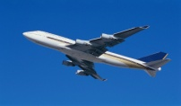 to Bologna. Unfortunately, the flight

**(be)** delayed so they **(have)** to wait 2 hours before they **(take)** off. After they had arrived to Bologna they **(have)** to wait in a long 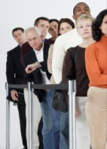 to the passport control and then for their C:\Users\ZielonyMost\AppData\Local\Microsoft\Windows\Temporary Internet Files\Content.IE5\G046ASVF\MC900055431[1].wmf . Then they **(head)** towards the railway station to catch the 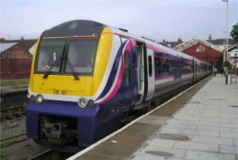 to Florence. When they **(reach)** the

platform, they **(realise)** they had missed the train and **(have)** to wait an hour

for the next one.

On the train, Sandra and Paul were planning what to visit first in Florence.

They **(agree)** they both **(want)** to see the famous 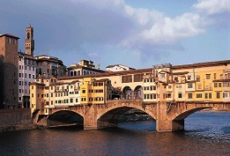 and the 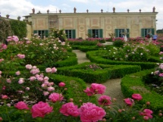 . After they had got off the train in Bologna, they **(look)** for

a 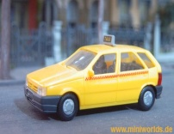 that would take them to the C:\Users\ZielonyMost\AppData\Local\Microsoft\Windows\Temporary Internet Files\Content.IE5\TFQ0UU8B\MC900297289[1].wmf. There **(be)** no

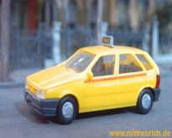 available so they **(decide)** to walk instead. On the way to the

C:\Users\ZielonyMost\AppData\Local\Microsoft\Windows\Temporary Internet Files\Content.IE5\TFQ0UU8B\MC900297289[1].wmfthey **(get)** lost and **(have)** to ask for directions several times.

Finally, they **(get)** to the C:\Users\ZielonyMost\AppData\Local\Microsoft\Windows\Temporary Internet Files\Content.IE5\TFQ0UU8B\MC900297289[1].wmf. After a quick snack they **(go)** straight to C:\Users\ZielonyMost\AppData\Local\Microsoft\Windows\Temporary Internet Files\Content.IE5\TFQ0UU8B\MC900030262[1].wmf. Next morning they **(get up)** and **(open)** the C:\Users\ZielonyMost\AppData\Local\Microsoft\Windows\Temporary Internet Files\Content.IE5\TFQ0UU8B\MC900030322[1].wmf . Outside it was  heavily…