Функция $y=\log_{5}{x}$

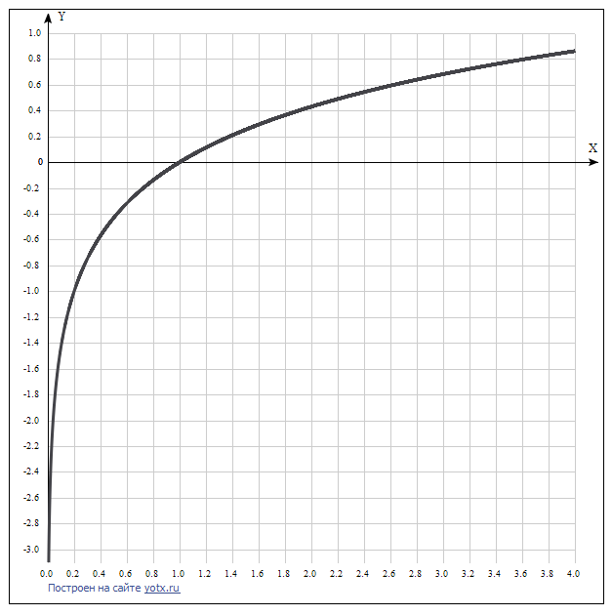

|  |  |
| --- | --- |
| **x** | **y** |
| 0.0 | - |
| 0.2 | -1 |
| 0.4 | -0.57 |
| 0.6 | -0.32 |
| 0.8 | -0.14 |
| 1.0 | 0 |
| 1.2 | 0.11 |
| 1.4 | 0.21 |
| 1.6 | 0.29 |
| 1.8 | 0.37 |
| 2.0 | 0.43 |
| 2.2 | 0.49 |
| 2.4 | 0.54 |
| 2.6 | 0.59 |
| 2.8 | 0.64 |
| 3.0 | 0.68 |
| 3.2 | 0.72 |
| 3.4 | 0.76 |
| 3.6 | 0.8 |
| 3.8 | 0.83 |
| 4.0 | 0.86 |