 integral_(-1)^2 (1+x^3) dx = 27\/4~~6.75

 integral (1+x^3) dx = x^4\/4+x+constant

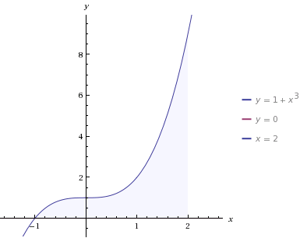и