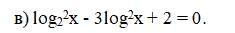
- t = log₂x
t²-3t+2=0
(t-1)(t-2)=0
t=1. Log₂x=1, x=2
t=2, log₂x=2, x=4

