1. **Заполни пропуски при помощи правильной формы глагола в скобках**

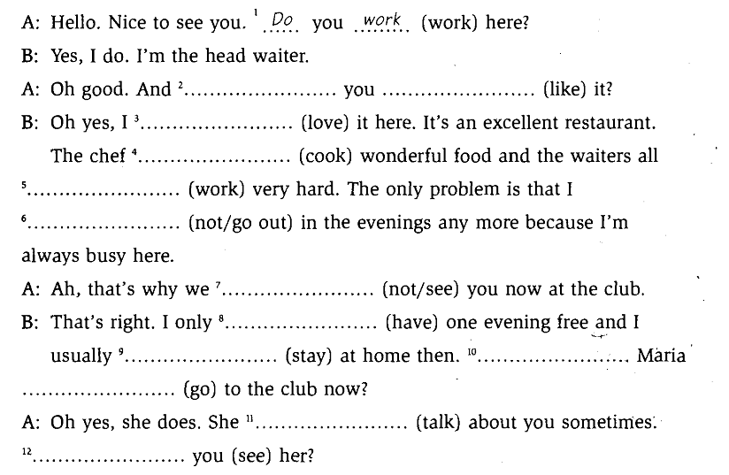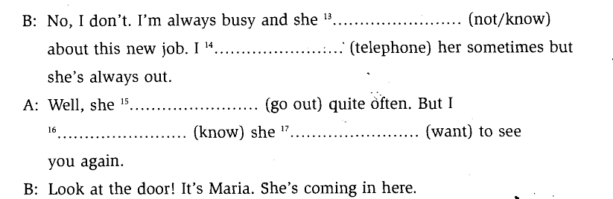

1. **Поставь предложения в отрицательную форму**

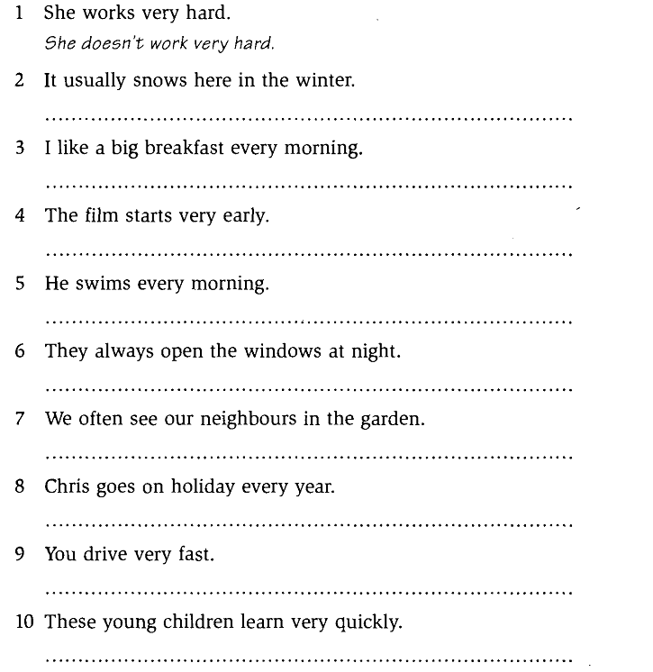

A: Oh good And do you like it?

B: I love

The chief cooks

work very hard

don`t go out

A:don`t see

B: I only have

I usually stay

Does Maria go

A: She talks

Do you see her?

B: she doesn`t know about this…

I telephone her sometimes

A:

She goes out

I know

she wants

2.

2. It usually doesn`t snow here…

3 I don`t like a big….

4 The film doesn`t start …

5 He doesn`t swim…

6. They always don`t open …

7 We often don`t see …

8 Chris doesn`t go on …

9 You don`t drive….

10 These young children don`t learn