$$y=x^{4}-4x^{3}+20$$

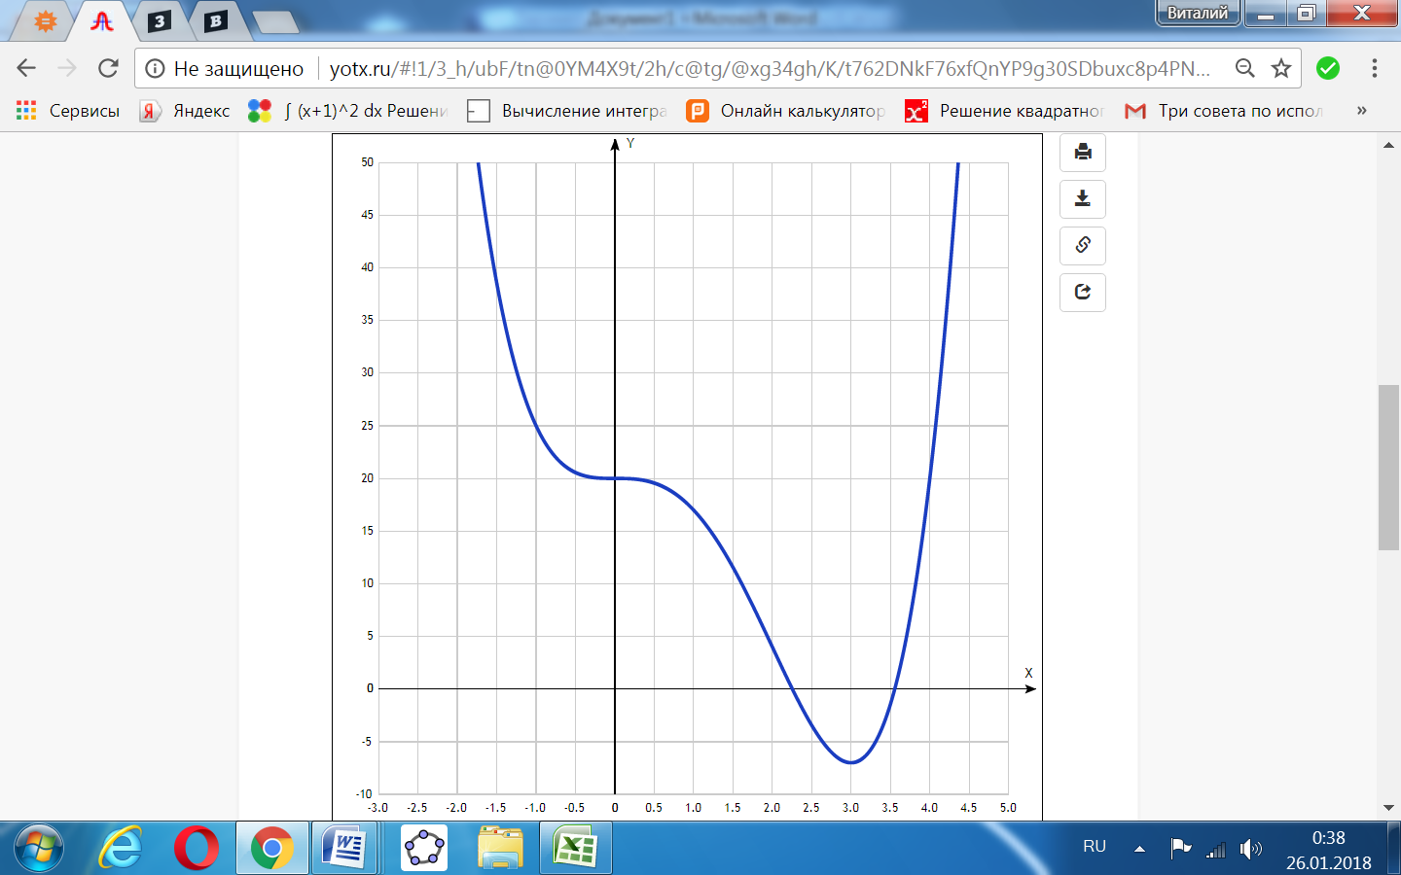

|  |  |
| --- | --- |
| **x** | **y** |
| -3.0 | 209 |
| -2.5 | 121.6 |
| -2.0 | 68 |
| -1.5 | 38.6 |
| -1.0 | 25 |
| -0.5 | 20.6 |
| 0 | 20 |
| 0.5 | 19.6 |
| 1.0 | 17 |
| 1.5 | 11.6 |
| 2.0 | 4 |
| 2.5 | -3.4 |
| 3.0 | -7 |
| 3.5 | -1.4 |
| 4.0 | 20 |
| 4.5 | 65.6 |
| 5.0 |  |