- 1) 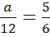; a=$\frac{\text{12}∗5}{6}$=10

2) 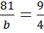; b=$\frac{\text{81}∗4}{9}$=36

3) 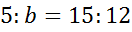 b=$\frac{5∗\text{12}}{\text{15}}$=4

4) 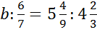; b=$\frac{6}{7}∗5\frac{4}{9}:4\frac{2}{3}$=$\frac{6∗\text{49}∗3}{7∗9∗\text{14}}$=1

5) 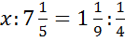 x=$7\frac{1}{5}∗1\frac{1}{9}:\frac{1}{4}$=$\frac{\text{36}∗\text{10}∗4}{5∗9∗1}$=32

6) 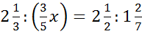 $\frac{3}{5}$x=$\frac{7∗9∗2}{3∗7∗5}$=$\frac{6}{5}$ x=2

7) 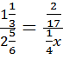; $\frac{1}{4}$x=$\frac{\text{17}∗2∗3}{6∗\text{17}∗4}$=$\frac{1}{4}$ x=1

8) 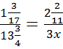 3x=$\frac{\text{55}∗\text{24}∗\text{17}}{4∗\text{11}∗\text{20}}$=29 x=7$\frac{2}{3}$

9) 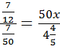 50x=$\frac{7∗\text{24}∗\text{50}}{\text{12}∗5∗7}$=20 x=$\frac{2}{5}$

10) 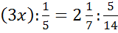 3x=$\frac{1∗\text{15}∗\text{14}}{5∗7∗5}$=$\frac{6}{5}$ x=$\frac{6∗1}{5∗3}$=$\frac{2}{5}$

