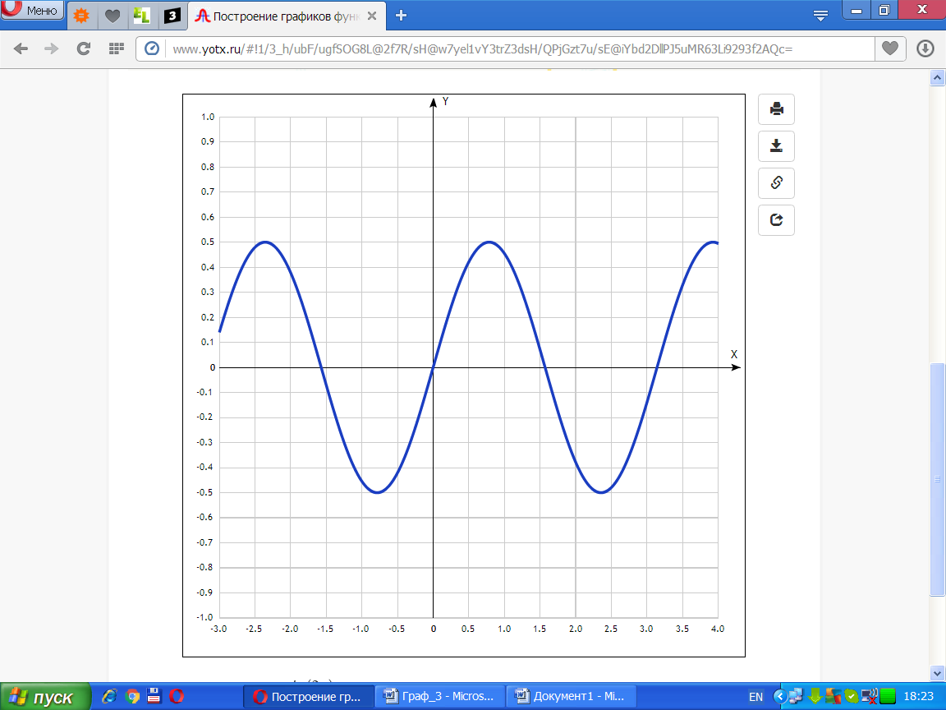

[Таблица точек](javascript:void(0);)

|  |  |
| --- | --- |
| **x** | **y** |
| -3.0 | 0.14 |
| -2.5 | 0.48 |
| -2.0 | 0.38 |
| -1.5 | -0.07 |
| -1.0 | -0.45 |
| -0.5 | -0.42 |
| 0 | 0 |
| 0.5 | 0.42 |
| 1.0 | 0.45 |
| 1.5 | 0.07 |
| 2.0 | -0.38 |
| 2.5 | -0.48 |
| 3.0 | -0.14 |
| 3.5 | 0.33 |
| 4.0 | 0.49 |

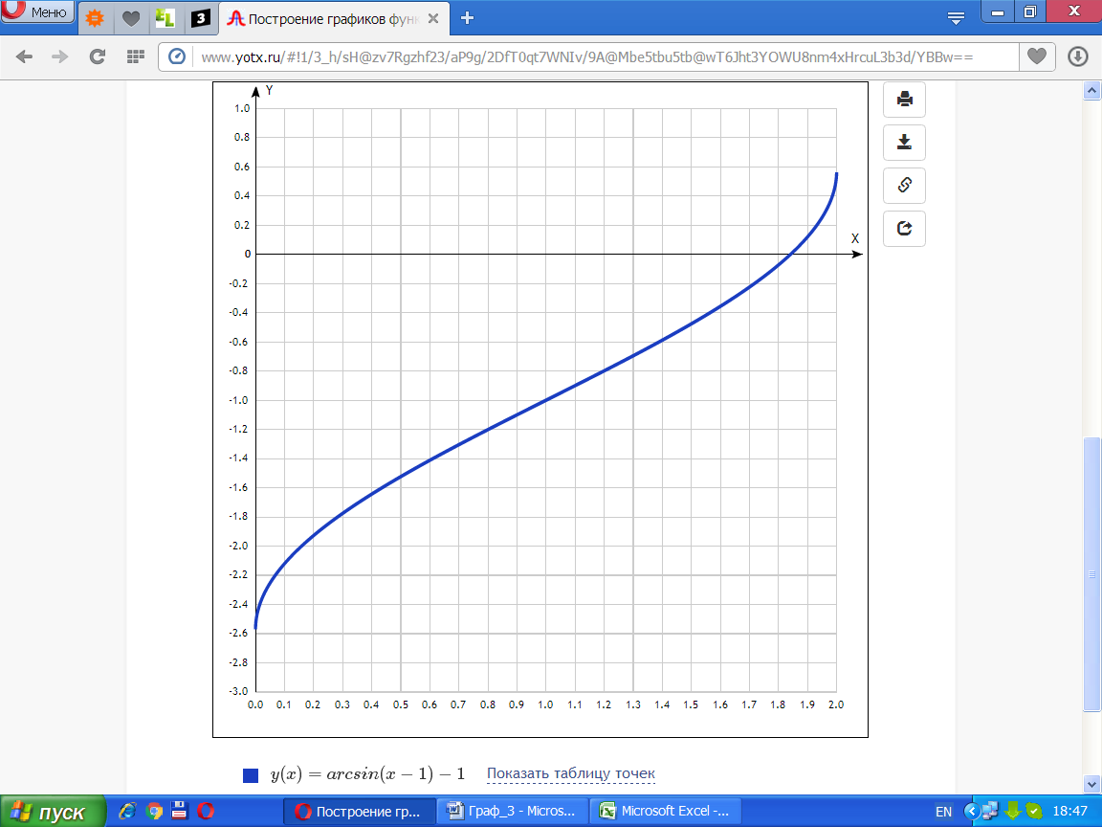

[Таблица точек](javascript:void(0);)

|  |  |
| --- | --- |
| **x** | **y** |
| 0.0 | -2.57 |
| 0.1 | -2.12 |
| 0.2 | -1.93 |
| 0.3 | -1.78 |
| 0.4 | -1.64 |
| 0.5 | -1.52 |
| 0.6 | -1.41 |
| 0.7 | -1.3 |
| 0.8 | -1.2 |
| 0.9 | -1.1 |
| 1.0 | -1 |
| 1.1 | -0.9 |
| 1.2 | -0.8 |
| 1.3 | -0.7 |
| 1.4 | -0.59 |
| 1.5 | -0.48 |
| 1.6 | -0.36 |
| 1.7 | -0.22 |
| 1.8 | -0.07 |
| 1.9 | 0.12 |
| 2.0 | - |