bc: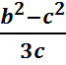 * 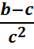= bc: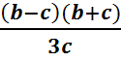 *
- bc:= bc*