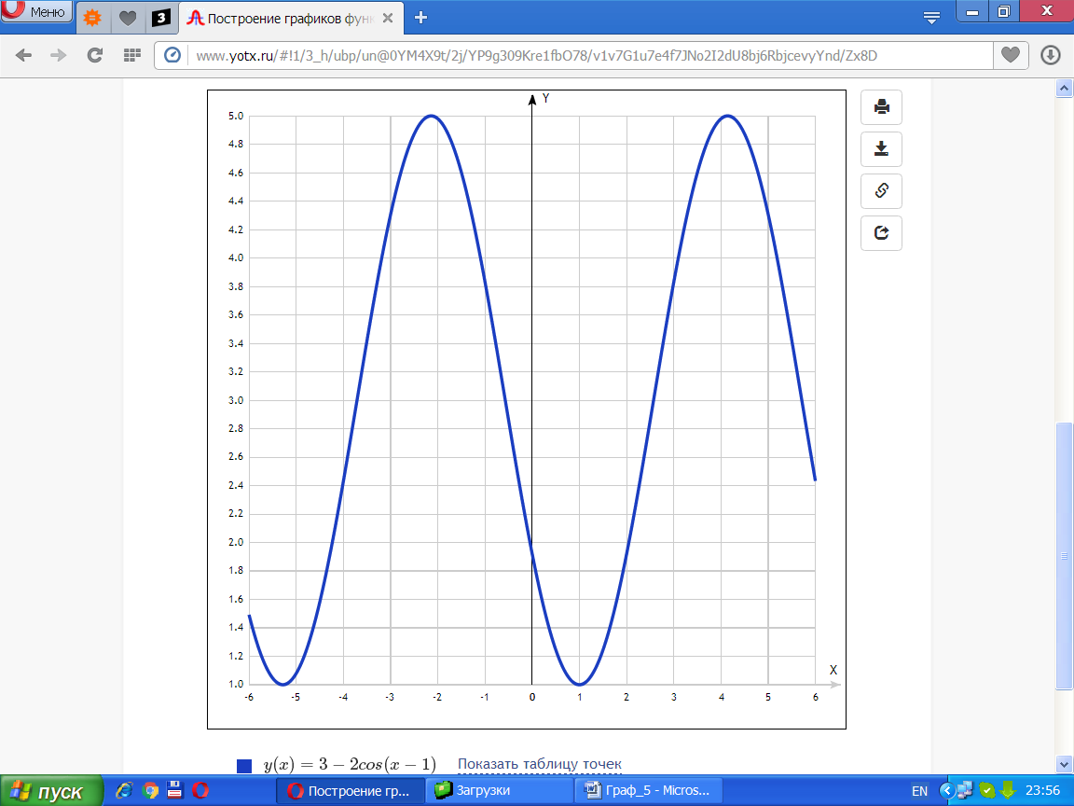

[Таблица точек](javascript:void(0);)

|  |  |
| --- | --- |
| **x** | **y** |
| -6 | 1.49 |
| -5 | 1.08 |
| -4 | 2.43 |
| -3 | 4.31 |
| -2 | 4.98 |
| -1 | 3.83 |
| 0 | 1.92 |
| 1 | 1 |
| 2 | 1.92 |
| 3 | 3.83 |
| 4 | 4.98 |
| 5 | 4.31 |
| 6 | 2.43 |