TEST

Present Simple vs. Present Continuous

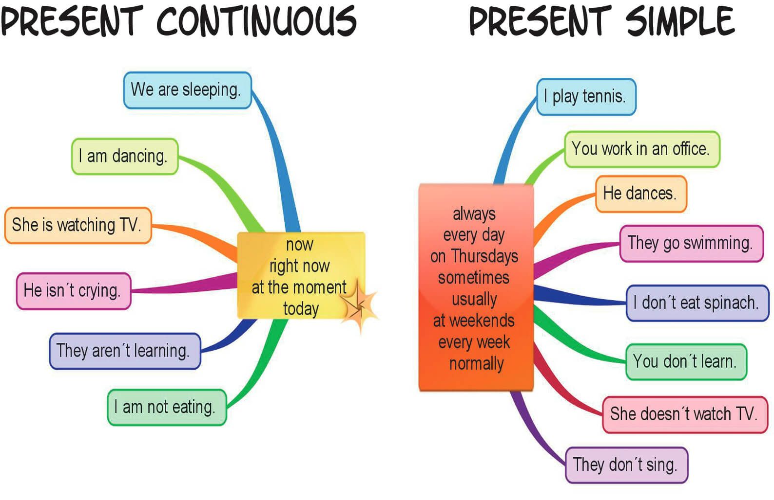

Use the verbs in brackets in ***Present Simple*** or ***Present* *Continuous***.

1) She **usually** …. (wear) jeans, but **now** she …. (wear) a beautiful dress.

2) **Look!** Tom …. (talk) to Jane.

3) Mum … (cook) dinner in the kitchen **now**.

4) She …. (cook) dinner **every day.**

5) Steve …. (play) football with his friends **on Saturdays**.

6) I …. (buy) magazines **every day**.

7) **Now** I … (read) one of them.

8) **Listen!** Sara … (play) the violin.

9) **Every evening** my father ….(cook) supper for us.

10) The sun…. (shine) **now**.

11) They **often**…. (listen) to music in their room.

12) She ….. (sit) in the armchair **at the moment**.

13) She **usually** …. (read) in the evening.