-y (-y/2-2/3) = -5 (-1/2+y/4)+(-y/6+7×y/12)

-(-y/2-2/3) y = (5 y)/12-5 (y/4-1/2)

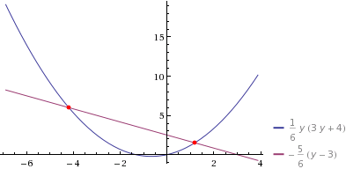

4/29 (y+3/2)^2 = 1

1/6 y (3 y+4) = -5/6 (y-3)

y^2/2+(3 y)/2-5/2 = 0

y^2/2+(2 y)/3 = (5 y)/12-5 (y/4-1/2)

y^2/2+(2 y)/3 = 5/2-(5 y)/6

y = -3/2-sqrt(29)/2

y = sqrt(29)/2-3/2