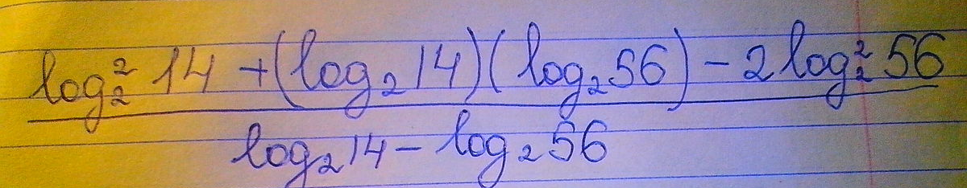
$$\begin{aligned}\frac{{\text{log}}_{2}^{2}\text{14}+\left({\text{log}}_{2}\text{14}\right)⋅\left({\text{log}}_{2}\text{56}\right)−2⋅{\text{log}}_{2}^{2}\text{56}}{{\text{log}}_{2}\text{14}−{\text{log}}_{2}\text{56}}= \\ \frac{{\text{log}}_{2}^{2}\text{14}+\left({\text{log}}_{2}\text{14}\right)⋅\left({\text{log}}_{2}\text{56}\right)−{\text{log}}_{2}^{2}\text{56}−{\text{log}}_{2}^{2}\text{56}}{{\text{log}}_{2}\text{14}−{\text{log}}_{2}\text{56}}=\text{группируем} \\ \frac{\left({\text{log}}_{2}^{2}\text{14}−{\text{log}}_{2}^{2}\text{56}\right)+\left(\left({\text{log}}_{2}\text{14}\right)⋅\left({\text{log}}_{2}\text{56}\right)−{\text{log}}_{2}^{2}\text{56}\right)}{{\text{log}}_{2}\text{14}−{\text{log}}_{2}\text{56}}= \\ \frac{\left({\text{log}}_{2}\text{14}−{\text{log}}_{2}\text{56}\right)⋅\left({\text{log}}_{2}\text{14}+{\text{log}}_{2}\text{56}\right)+\left({\text{log}}_{2}\text{56}\right)⋅\left({\text{log}}_{2}\text{14}−{\text{log}}_{2}\text{56}\right)}{{\text{log}}_{2}\text{14}−{\text{log}}_{2}\text{56}}= \\ \frac{\left({\text{log}}_{2}\text{14}−{\text{log}}_{2}\text{56}\right)⋅\left({\text{log}}_{2}\text{14}+{\text{log}}_{2}\text{56}+{\text{log}}_{2}\text{56}\right)}{{\text{log}}_{2}\text{14}−{\text{log}}_{2}\text{56}}={\text{log}}_{2}\text{14}+{\text{log}}_{2}\text{56}+{\text{log}}_{2}\text{56}= \\ {\text{log}}_{2}\text{14}+2⋅{\text{log}}_{2}\text{56}={\text{log}}_{2}\text{14}+2⋅{\text{log}}_{2}\left(\text{14}⋅4\right)={\text{log}}_{2}\text{14}+2⋅\left({\text{log}}_{2}\text{14}+{\text{log}}_{2}4\right)=3⋅{\text{log}}_{2}\text{14}+4= \\ 3⋅{\text{log}}_{2}\left(2⋅7\right)+4=3⋅\left({\text{log}}_{2}2+{\text{log}}_{2}7\right)+4=6+2⋅{\text{log}}_{2}7+4=\text{10}+2⋅{\text{log}}_{2}7\end{aligned}$$

