http://www4f.wolframalpha.com/Calculate/MSP/MSP42132277deg1e38ac7c900000faaf0igh0e3bhb3?MSPStoreType=image/gif&s=55&w=218.&h=36.

http://www4f.wolframalpha.com/Calculate/MSP/MSP17942277dia634546037000010edeag9hice867c?MSPStoreType=image/gif&s=55&w=321.&h=51.

http://www4f.wolframalpha.com/Calculate/MSP/MSP17972277dia634546037000052hi5c8h1h5h60di?MSPStoreType=image/gif&s=55&w=322.&h=51.

http://www4f.wolframalpha.com/Calculate/MSP/MSP18002277dia634546037000035e24ad4088902bd?MSPStoreType=image/gif&s=55&w=321.&h=51.

http://www4f.wolframalpha.com/Calculate/MSP/MSP18032277dia63454603700005a0461gh243e88ii?MSPStoreType=image/gif&s=55&w=322.&h=51.

График функций 3cos2t и 2sin2t

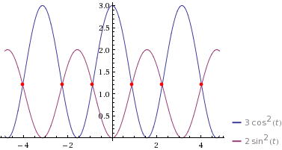

Значения х и у при разных значениях t

|  |  |  |  |  |  |  |  |  |  |  |  |
| --- | --- | --- | --- | --- | --- | --- | --- | --- | --- | --- | --- |
| t | 0 | 1 | 2 | 3 | 4 | 5 | 6 | 7 | 8 | 9 | 10 |
| 3cos^2(t)=x | 3 | 0.876 | 0.520 | 2.940 | 1.282 | 0.241 | 2.766 | 1.705 | 0.064 | 2.491 | 2.112 |
| 2sin^2(t)=y | 0 | 1.416 | 1.6536 | 0.0398 | 1.1455 | 1.8391 | 0.1561 | 0.8633 | 1.9577 | 0.3397 | 0.5919 |