3 x^2+2 x-1<=0

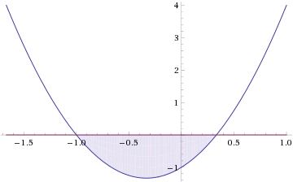

-1<=x<=1\/3