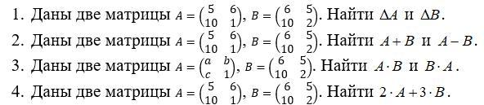

1) ΔA = 5\*1 - 6\*10 = -55.

ΔB = 6\*2 - 5\*10 = -38.

2) A + B = 11 11 A - B = -1 1

20 3 0 -1.

3)

=

=

4) .

.