Theme: Work and money

**Read the text**

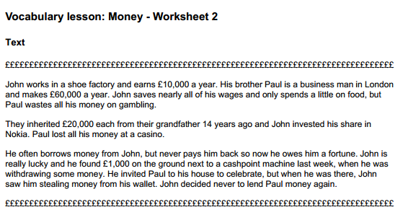

**Answer the questions YES/NO**

1.Are John and Paul brothers?

2.Does John work in a shop?

3.Did Paul waste all his money at a casino?

4. Did they inherit 10000 each from their grandfather?

5. Does Paul often borrow money from John?

6. Did Paul find money next to a cashpoint?

7. Did Paul steal money from John’s wallet?

